Throughout the entire assignment, exhibits will be imbedded within the main document to enhance the reading experience by preventing the reader from flipping between pages. Calculated R Squared, Adjusted R Squared, Coefficients P-Values, and Significance F-Values will be expressed in the images.

**Problem 1:**

A.

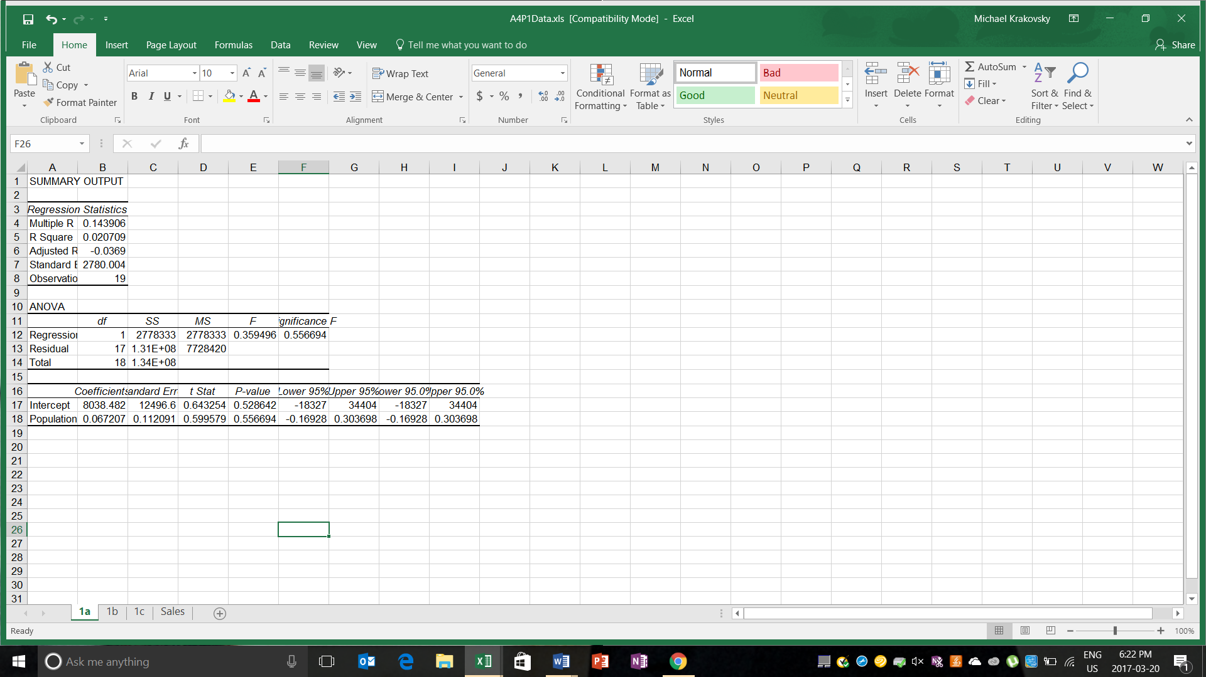

Figure 1: Regression between Sales (Response) and Population (Explanatory)

From the regression model in Figure 1, we can derive the simple linear regression.

Annual Sales = 8038.482 + 0.0672 * (Population)

The results from the simple regression model in excel are alarming because of a lack of credibility. The R Squared value is a mere 0.0207 while the Adjusted R Squared is -0.0369. Since both values are extremely low, the model is inaccurate. The F value, the regression intercept, and the population coefficients in the model are not significant from 0 at 5%; therefore, the current model cannot be used to accurately predict sales.

B.

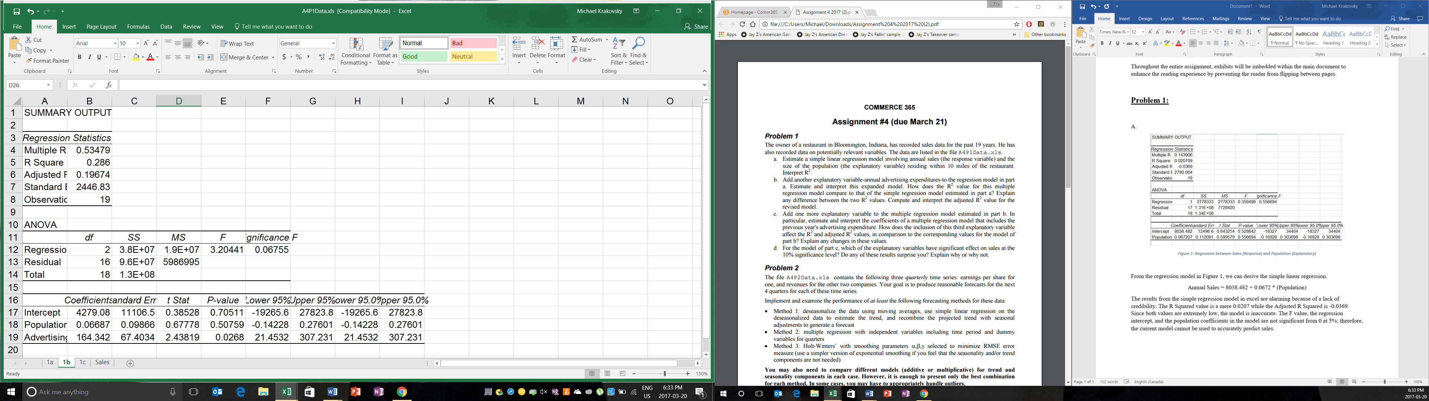

Figure 2: Regression between Sales (Responsive), Advertising Expenditures & Population (Explanatory)

The new model from the regression can be expressed as:

Annual Sales = 4279.08 + 0.06687 * Population + 164.342 * Advertising

The new model is more accurate than the model in question A. First, the R Squared and Adjusted R Squared values are both significantly higher than the values in the first model, which indicates a model with higher accuracy. However, they are still low thus suggesting an inaccurate model. Second, the Significant F is very close to the 5% level of significance which indicates that the coefficients within the model are different from 0. Finally, the advertising coefficient is different from 0 at a 5% confidence interval; however, the intercept and population coefficients still lack significance.

C.

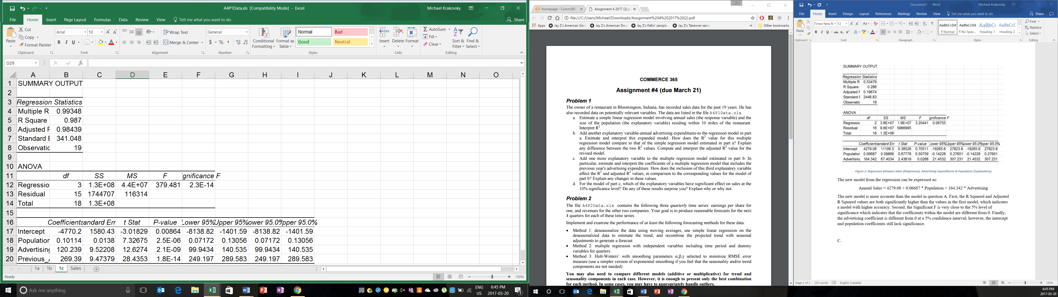

Figure 3: Regression between Sales (Responsive), Population, Advertising & Previous Advertising (Explanatory)

The newest model can be expressed as:

Annual Sales = -4770.2 + 0.1011 * Population + 120.239 * Advertising + 269.39 * (Prev. Advertising)

The model in question C, outperforms all other models for multiple reasons. First, the R Squared and the Adjusted R Squared values are close to 100%, which is much higher then the R values of the last two models. Therefore, the model in question C is extremely accurate. The Significance F and coefficient P values are all significant at the 5% confidence interval indicating significant coefficient values for every variable. By including the Previous Advertising variable, the model becomes incredibly accurate and usable to predict Annual Sales in the future.

D.

As mentioned in the previous answer, all variables now have a significant effect on Sales at the 10% confidence interval once the Previous Advertising variable is added. The results do not surprise me because it seems reasonable that the variables within the model should influence the performance of a business. For example, spending more on advertising will attract more customers thus increasing sales. In addition, a growing population close to the business will lead to more demand, which will also increase the amount of annual sales.

**Problem 2:**

Analysis of Data Set One (EPS):

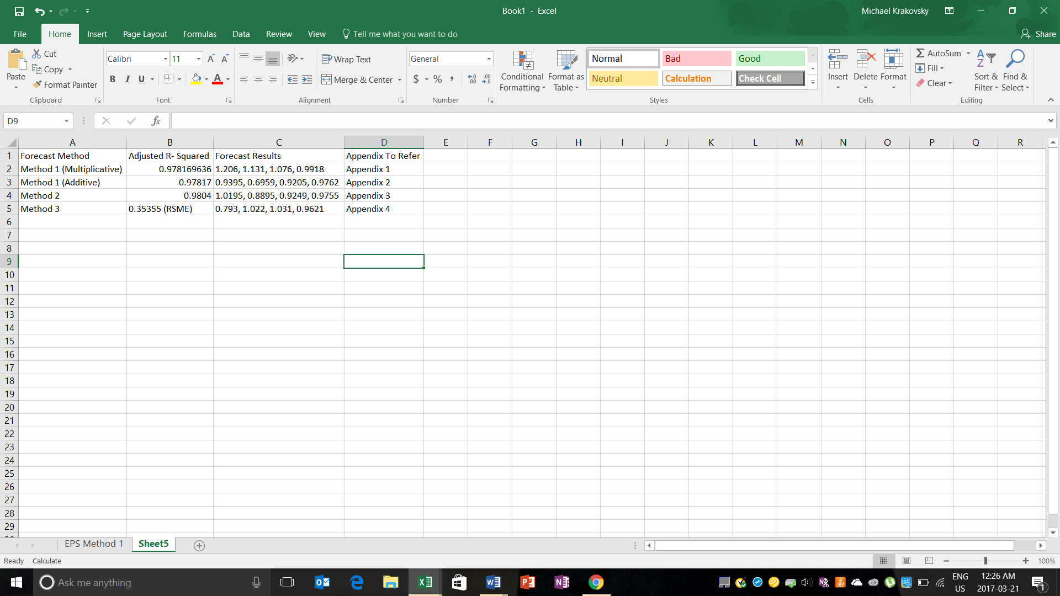

The best method to forecast the data in Data Set One is Method 2. The first step in choosing the best model was to graph the data. Second, once the data was graphed, we noticed an outlier that needed to be removed. In the first two methods, we used a single dummy that signaled an outlier. Within the third method, we took the average of all the values in the same quarter prior to the outlier since utilizing dummies was not possible with the Holt-Winters Method. Third, we attempted to identify the type of seasonality within the data series; however, the type of seasonality could not be observed. Therefore, we attempted a regression model using both multiplicative and additive. Although the accuracy of the first two models were quite accurate, the Adjusted R-Squared value within the third model was the highest among the three models. The final step was deciding whether to choose Method 2 and Method 3, which is more difficult since comparing the Adjusted R- Squared Values and RSME is not feasible. When the RSME was calculated with the outlier, Method 2 contained the lowest RSME. Therefore, we will rely on the Method 2 forecast to predict future EPS.

Analysis of Data Set 2 (Revenue):

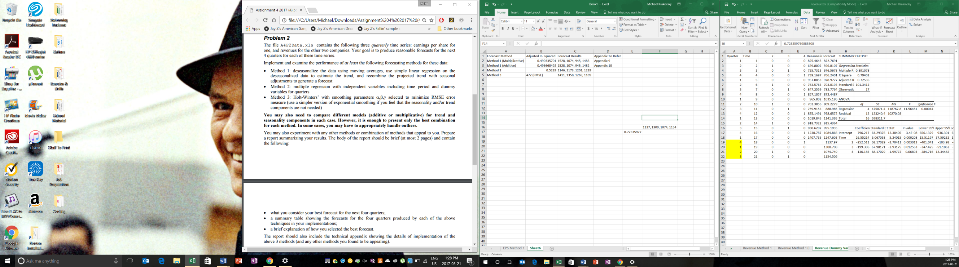



The best tool to forecast the given data is Method 3. First, we graphed the data to notice any patterns that can aid the forecasting process. When the data was graphed, their appeared to be noticeable trend and seasonality; however, the seasonality cannot be distinguished between Additive and Multiplicative. Therefore, we performed a simple regression model using both deseasonalization techniques and found the Multiplicative method to be more accurate because of a significantly higher Adjusted R- Squared Value. Second, we used the deseasonalized data from Method 1 (Multiplicative), and created a regressive model against dummies for every quarter. Surprisingly, the Adjusted R- Squared was marginally better than the simple regressive model in Method 1 which made the third model the best out of the three. Third, we used the deseasonalized data from Method 1 and attempted to create a Holt-Winters model by minimizing the RSME. Finally, we calculate the RMSE of Method 2 to compare the accuracy of our two best models. The calculated RSME of Method 3 was much lower thus indicating a more accurate model and better forecasts for the next four quarters.

Analysis of Data Set 3:

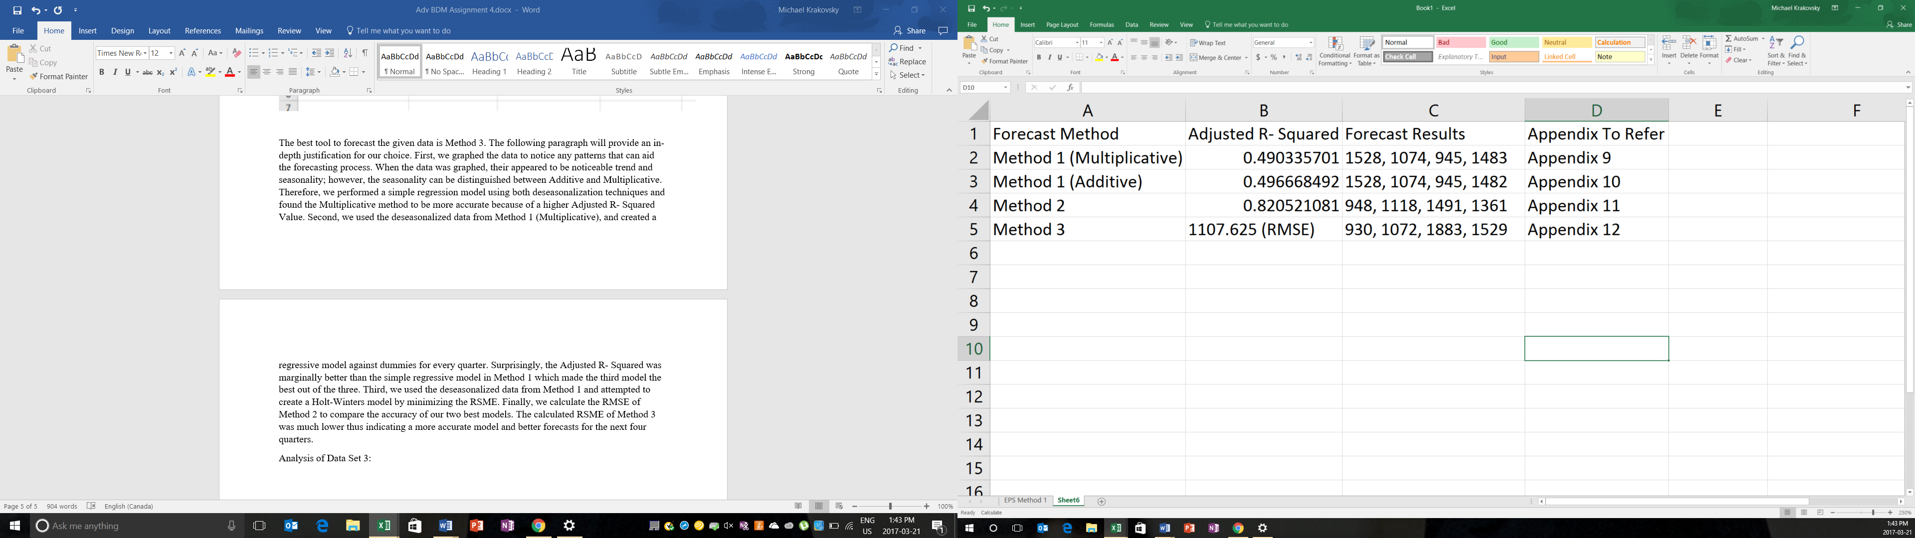

The best method to forecast the data in Data Set One is Method 2. Like the analysis of the last two data sets, the first step is to graph the data. The data did not contain any outliers and appeared to contain an upward trend. The seasonality appeared to multiplicative since with each drop within the data set, the next season contained a greater increase in revenue. However, we modeled both types of seasonalities within a simple regression model and found the Adjusted R- Squared values to be close together. Therefore, we relied on intuition from observing the graph and utilized multiplicative deseasonalized data. Second, we utilized regression against dummy variables for every quarter and created a model with a significantly higher Adjusted R- Squared value then the previous models. Third, we modelled the data using Holt-Winters method and derived the lowest possible RMSE. However, the RSME of Method 2 was lower thus indicating a model of greater accuracy. Therefore, the forecasts that we are most confident with are those from Method 2.

**Problem 3:**

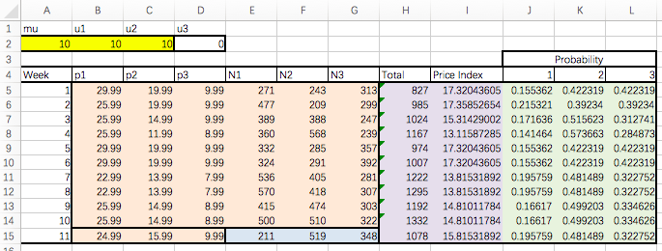From the given formula,



We can calculate all purchase probabilities in 11 weeks, shown in the green boxes on the right. For example, for Probability 1, week 1, we use:

=EXP(($B$2-$B5)/$A$2)/(EXP(($B$2-$B5)/$A$2)+EXP(($C$2-$C5)/$A$2)+EXP(($D$2-$D5)/$A$2))

1. To calculate an explanatory variable, we have the price index for 11 weeks in the purple boxes. With the formula,



e.g. for Price Index for week 1, we use =B5*J5+C5*K5+D5*L5 in excel.

If the Total Sales and Price Index follow a simple linear regression model, we can model the total sales as

*Total Sales = 2314.287 – 78.1785 * Price Index*

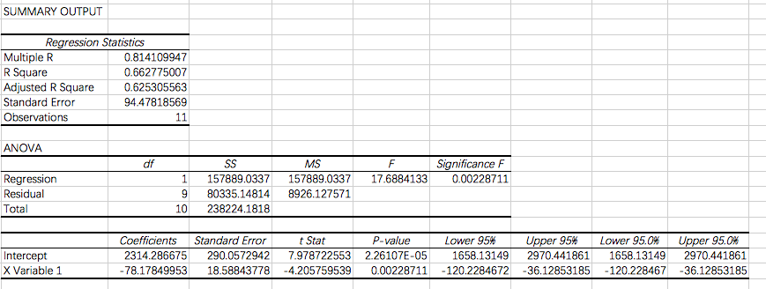

As R square and adjusted R square are both relatively high, and the P value for the explanatory variable is low enough, we found this model as a reliable way of portraying the relationship between Price Index and Total sales. Thus, with the price index in week 11 that we already calculated, we can easily find the forecasted total sales in week 11 by simply inserting the input into the model. As for the sales of each individual type of goods, we multiple the total sales number with the probability of purchasing each type of goods.

E.g. For N1 in week 11, sales =ROUND($H$15*J15,0)

C.

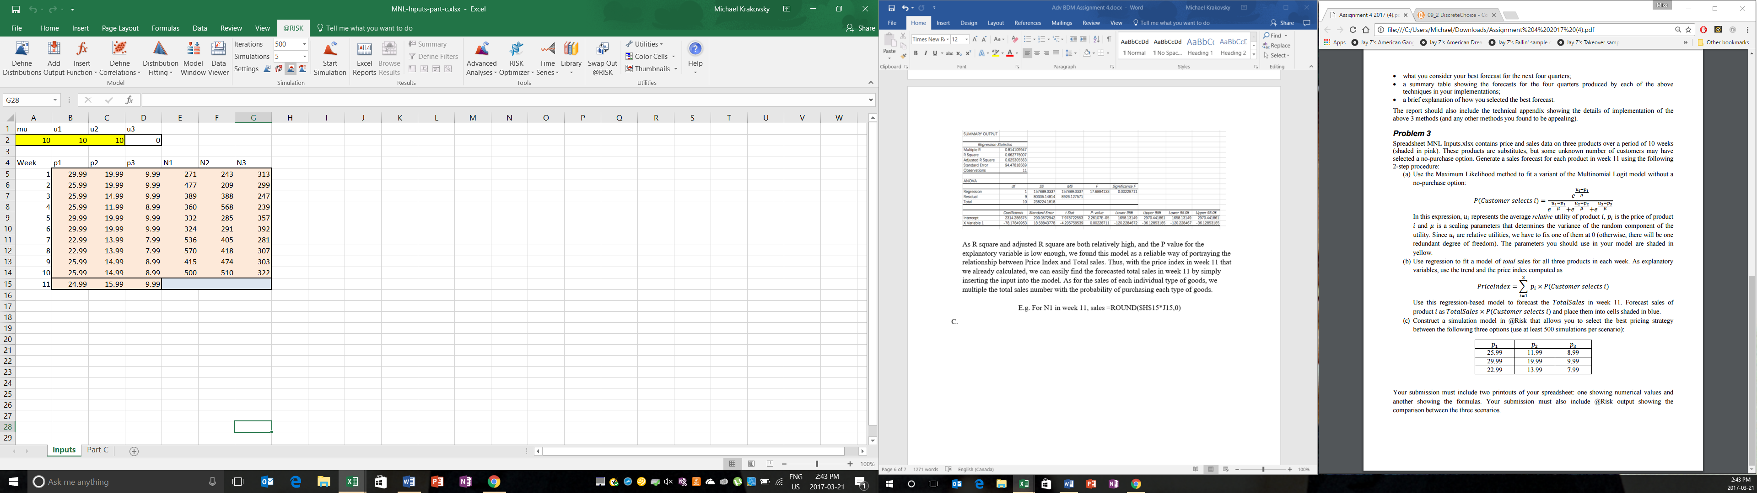

Figure 4: Inputs Used In @Risk

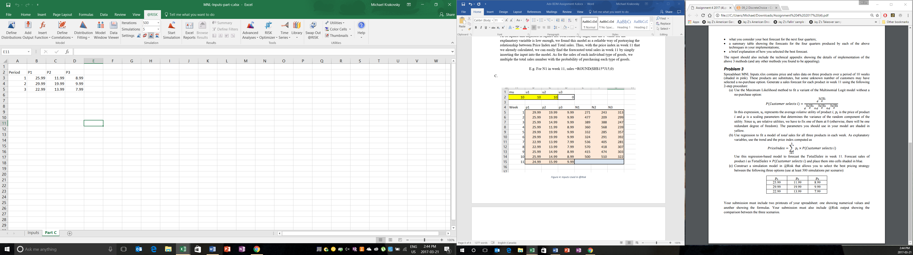

Figure 5: Possible Pricing Strategies in @Risk